Git – 01 & git-02
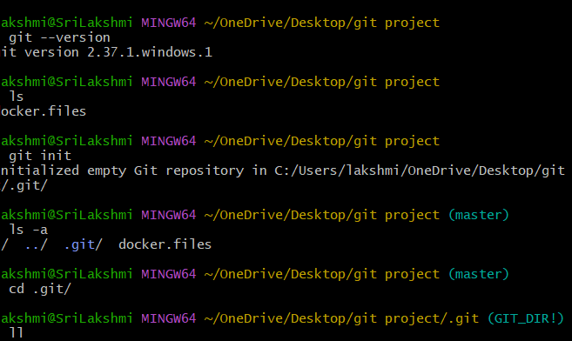
Git –-version -: which version is installing in laptop ( or ) if it is not installed go to https://git-scm.com download for windows
Git init -: starting step ( inside the project)
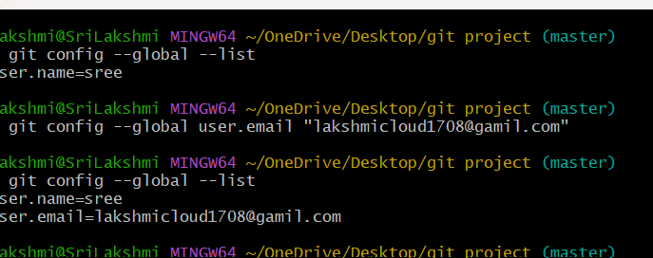
git config --global user.name “sree”
git config --global user.email lakshmicloud1708@gamil.com
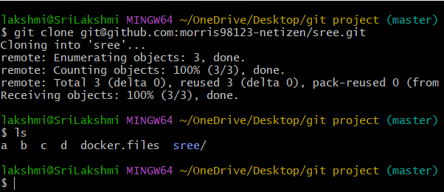
Git clone :- complete details about projects

Creat a github account / create 1 diretory and create a files
After that move all files into directory
Generate the key - ssh -keygen
Git status – check the status of traced and untracked files
Git commit -m “message” - help to create a message
Git remove add origin <url> - add the remote to git hub
Git push -u origin main – it is used push the code

Git hub-02
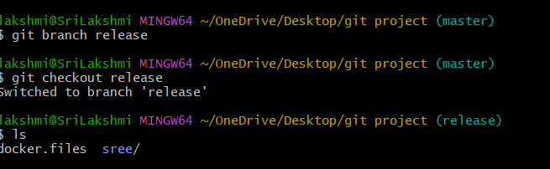

Git branch < bname> :- it is used to create a branch
Git checkout <newbname> :- to swtich the oldbrance to new branch
Git checkout -b <branch nam
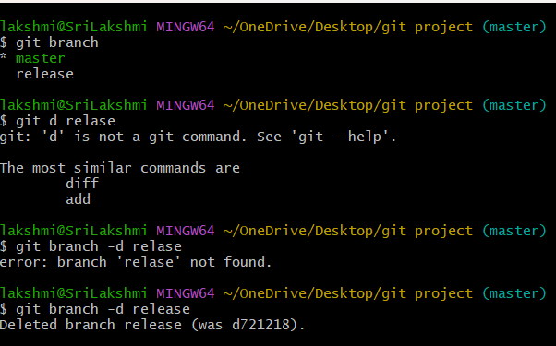
Git branch – create a branch
Git branch -d – delete the branch
Git checkout (branch name) – switch the branch
git cherry-pick : - taking commit form on brach and apply it on another branch
git merge – to combined the 2 branches all files in one branch

